**Quick Start Guide**

Download Construct 2 from [here](https://www.scirra.com/construct2/releases/r227)



Open ‘Zombie Math’.caproj file.

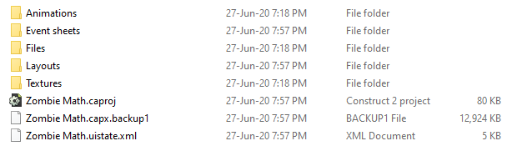

**Start reskinning game !! ☺**